iPad Apps for Kindergarten
- Native Numbers – (classroom code from teacher)
https://apps.apple.com/us/app/native-numbers/id570231808

- Bedtime Math
https://apps.apple.com/us/app/bedtime-math/id637910701
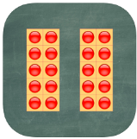
- Number Flash
https://apps.apple.com/us/app/number-flash/id610929803
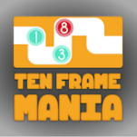
- Ten Frame Mania
https://apps.apple.com/us/app/ten-frame-mania/id1018365345
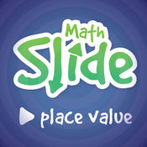
- Math Slide (Place Value) $
https://apps.apple.com/us/app/math-slide-place-value/id601161731

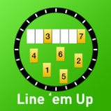
- Line ‘em Up
https://apps.apple.com/us/app/line-em-up/id419041848

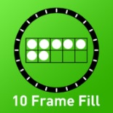
- 10 Frame Fill
https://apps.apple.com/us/app/10-frame-fill/id418083871
- Quick Math Jr. https://apps.apple.com/us/app/quick-math-jr/id926078360

- Todo Math
https://apps.apple.com/us/app/todo-math/id666465255

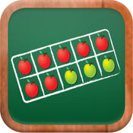
- MathTappers: Find Sums
https://apps.apple.com/us/app/mathtappers-find-sums-math-game-to-help-children-learn/id353582286

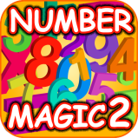
- Number Magic 2
https://apps.apple.com/us/app/123-number-magic-line-matching/id468534094

- Addimals
https://apps.apple.com/us/app/teachley-addimals-edu/id1135468446

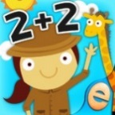
- Animal Math
https://apps.apple.com/us/app/animal-math-games-for-kids-in-pre-k-kindergarten-1st/id799973028
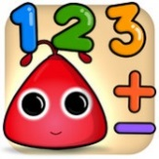
- Math Up K
https://apps.apple.com/us/app/math-up-k/id725956643#?platform=ipad

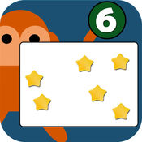
- Subitizing $
https://apps.apple.com/us/app/subitizing-flash-cards/id515943889

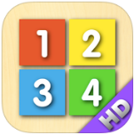
- Counting Board
https://apps.apple.com/us/app/counting-board/id450751745

