iPad Apps for Kindergarten
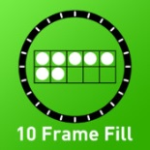
- 10 Frame Fill
https://itunes.apple.com/us/app/10-frame-fill/id418083871?mt=8

- Native Numbers
https://itunes.apple.com/us/app/native-numbers-complete-number-sense-mastery-curriculum/id570231808?mt=8

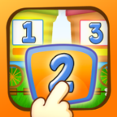
- Preschool Numbers
https://itunes.apple.com/us/app/preschool-numbers-play-learn-hd-lite/id586225920?mt=8
- Todo Math
https://itunes.apple.com/us/app/todo-math/id666465255?mt=8
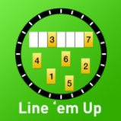
- Line ‘em Up
https://itunes.apple.com/us/app/line-em-up/id419041848?mt=8

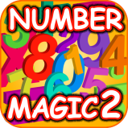
- Number Magic 2
https://itunes.apple.com/us/app/123-number-magic-line-matching/id468534094?mt=8

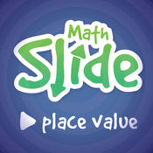
- Math Slide (Place Value)
https://itunes.apple.com/us/app/math-slide-place-value-school-edition/id601161731?mt=8

- Addimals
https://itunes.apple.com/us/app/teachley-addimals-edu/id1135468446?mt=8

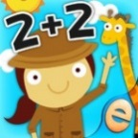
- Animal Math
https://itunes.apple.com/us/app/animal-math-games-for-kids-in-pre-k-kindergarten-1st/id799973028?mt=8
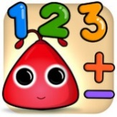
- Math Up K
https://itunes.apple.com/us/app/math-up-k/id725956643?mt=8

- Math!
https://itunes.apple.com/us/app/kids-number-addition-subtraction-math-ed-games/id529563132?mt=8

- Addition
https://itunes.apple.com/us/app/counting-addition-math-numbers-educational-games-for/id438688984?mt=8

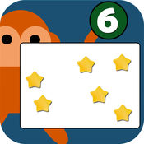
- Subitizing
https://itunes.apple.com/us/app/subitizing-flash-cards/id515943889?mt=8

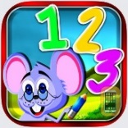
- Number Wonder
https://itunes.apple.com/au/app/number-wonder-teaching-math-skills-addition-subtraction/id839484092?mt=8
- Quick Math Jr.
https://itunes.apple.com/us/app/quick-math-jr/id926078360?mt=8

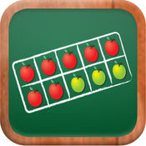
- MathTappers: Find Sums
https://itunes.apple.com/us/app/mathtappers-find-sums-math-game-to-help-children-learn/id353582286?mt=8
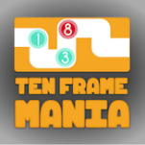
- Ten Frame Mania
https://itunes.apple.com/us/app/ten-frame-mania/id1018365345?mt=8
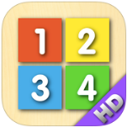
- Counting Board
https://itunes.apple.com/us/app/counting-board/id450751745?mt=8

