iPad Apps for Mult. & Div.
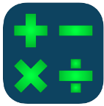
- Fast Facts Math $
https://apps.apple.com/us/app/fast-facts-math/id506232953

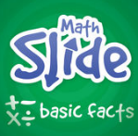
- Math Slide Basic Facts $
https://apps.apple.com/us/app/math-slide-basic-facts/id601161318

- Sushi Monster
https://apps.apple.com/us/app/sushi-monster/id512651258?ign-mpt=uo%3D4
- Quick Math $
https://apps.apple.com/us/app/quick-math-multiplication-table-arithmetic-game/id537802071

- Number Bubbles
https://apps.apple.com/us/app/addition-multiplication-number-bubbles/id467091416

- Multiplication 19x19 $
https://apps.apple.com/us/app/multiplication-genius-x19-free/id406611368

- 24 Game $
https://apps.apple.com/us/app/24-game-math-card-puzzle/id406854624

