iPad Apps for Add. & Sub.
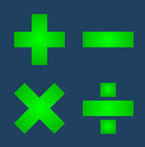
- Fast Facts Math $
https://apps.apple.com/us/app/fast-facts-math/id506232953
- Sushi Monster
https://apps.apple.com/us/app/sushi-monster/id512651258?ign-mpt=uo%3D4

- Quick Math $
https://apps.apple.com/us/app/quick-math-multiplication-table-arithmetic-game/id537802071

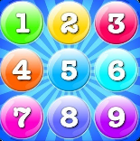
- Number Bubbles
https://apps.apple.com/us/app/addition-multiplication-number-bubbles/id467091416
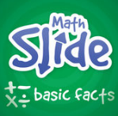
- Math Slide Basic Facts $
https://apps.apple.com/us/app/math-slide-basic-facts/id601161318

- Math Dots (any version)
https://apps.apple.com/us/app/math-dots-dinosaur-connect-to-dot-puzzle-kids-flashcard/id527197872

- Math Racing
https://apps.apple.com/us/app/math-racing-turbo-free-game/id521219858

