iPad Apps for Add. & Sub.
- Quick Math +
https://itunes.apple.com/us/app/quick-math/id703287370?mt=8
- Sushi Monster
https://itunes.apple.com/us/app/sushi-monster/id512651258?mt=8

- Quick Math
https://itunes.apple.com/us/app/quick-math-multiplication-table-arithmetic-game/id537802071?mt=8

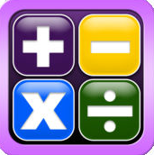
- Math Splash Bingo
https://itunes.apple.com/us/app/math-splash-bingo-fun-numbers-academy-games-drills/id578643350?mt=8

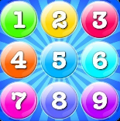
- Number Bubbles
https://itunes.apple.com/us/app/addition-multiplication-number-bubbles/id467091416?mt=8
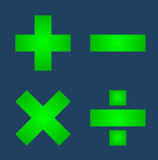
- Fast Facts Math
https://itunes.apple.com/us/app/fast-facts-math/id506232953?mt=8

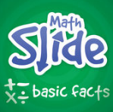
- Math Slide Basic Facts
https://itunes.apple.com/us/app/math-slide-basic-facts-school-edition/id601161318?mt=8
- Fast Facts Early Add
https://itunes.apple.com/us/app/fast-facts-early-add/id498801331?mt=8

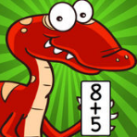
- Math Dots (any version)
https://itunes.apple.com/us/app/math-dots-dinosaur-connect-to-dot-puzzle-kids-flashcard/id527197872?mt=8

- Math Racing
https://itunes.apple.com/us/app/math-racing-turbo-free-game/id521219858?mt=8

