Challenging iPad Apps

- Unroll Me
https://apps.apple.com/us/app/unroll-me-unblock-the-slots/id769574372

- Logic Puzzles
https://apps.apple.com/us/app/logic-puzzles-classic-logic-grid-problems/id573935171
- Tangrams
https://apps.apple.com/us/app/pocket-tangrams/id503843068
- Zentomino
https://apps.apple.com/us/app/zentomino-free-relaxing-alternative-to-tangram-puzzles/id306937067

- Tynker
https://apps.apple.com/us/app/tynker-learn-to-code-programming-made-easy/id805869467
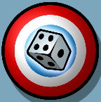
- 5-Dice
https://apps.apple.com/us/app/5-dice-order-of-operations-game/id572774867

- Five-O
https://apps.apple.com/us/app/five-o-free/id408157861

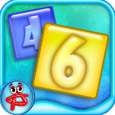
- Numbers (Absolutist)
https://apps.apple.com/us/app/numbers-logic-puzzle/id498473975

- Ken-Ken
https://apps.apple.com/us/app/kenken-classic/id485694706

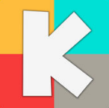
- Kakooma
https://apps.apple.com/us/app/kakooma/id978423277
- Solve Me Mobiles
https://apps.apple.com/us/app/solveme-mobiles/id977720372

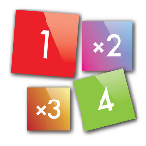
- Duprix
https://apps.apple.com/us/app/duprix/id591627954
- 1010 Block Plus
https://apps.apple.com/us/app/1010-block-puzzle-game/id911793120

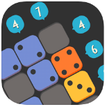
- Puzzle Ten
https://apps.apple.com/us/app/id1472714166

