Challenging iPad Apps

- Unroll Me
https://itunes.apple.com/us/app/unroll-me-unblock-the-slots/id769574372?mt=8

- Logic Puzzles
https://itunes.apple.com/us/app/logic-puzzles-classic-logic-grid-problems/id573935171?mt=8
- Tangrams
https://itunes.apple.com/us/app/pocket-tangrams/id503843068?mt=8

- Zentomino
https://itunes.apple.com/us/app/zentomino-free-relaxing-alternative-to-tangram-puzzles/id306937067?mt=8

- Tynker
https://itunes.apple.com/us/app/tynker-learn-to-code-programming-made-easy/id805869467?mt=8

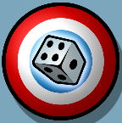
- 5-Dice
https://itunes.apple.com/us/app/5-dice-order-of-operations-game/id572774867?mt=8
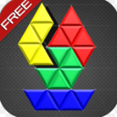
- beHEXed Free
https://itunes.apple.com/us/app/behexed-free/id661723598?mt=8
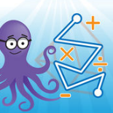
- Pick-a-Path
https://itunes.apple.com/us/app/pick-a-path/id545185507?mt=8
- Five-O
https://itunes.apple.com/us/app/five-o-free/id408157861?mt=8
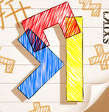
- tRixs
https://itunes.apple.com/au/app/trixs/id500490991?mt=8
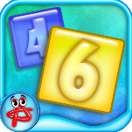
- Numbers (Absolutist)
https://itunes.apple.com/us/app/numbers-logic-puzzle/id498473975?mt=8
- Ken-Ken
https://itunes.apple.com/us/app/kenken-classic/id485694706?mt=8
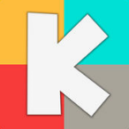
- Kakooma
https://itunes.apple.com/us/app/kakooma/id978423277?mt=8
- Solve Me Mobiles
https://itunes.apple.com/us/app/solveme-mobiles/id977720372?mt=8
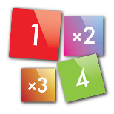
- Duprix
https://itunes.apple.com/us/app/duprix/id591627954?mt=8

- 1010 Block Plus
https://itunes.apple.com/us/app/1010-block-puzzle-mania/id1046281116?mt=8

- 10 10 10 10
https://itunes.apple.com/us/app/10101010-block-puzzle-10-10-color-brick-scale/id1059969330?mt=8

