iPad Apps for 4th Grade

- Bedtime Math
  - https://apps.apple.com/us/app/bedtime-math/id637910701

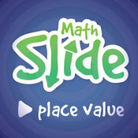
- Math Slide (Place Value) $
https://apps.apple.com/us/app/math-slide-place-value/id601161731

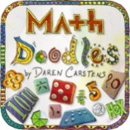
- Math Doodles $
https://apps.apple.com/us/app/math-doodles/id526959716

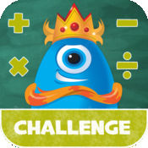
- Math Champ Challenge
https://apps.apple.com/us/app/math-champ-challenge-common-core-standards/id566463831

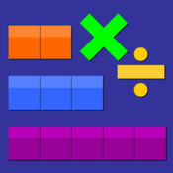
- Thinking Blocks Mult. & Div.
https://apps.apple.com/us/app/thinking-blocks-multiplication/id669725575

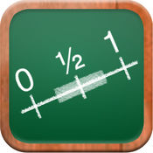
- Math Tappers Fractions
https://apps.apple.com/us/app/mathtappers-estimate-fractions-math-game-to-help-children/id353282053

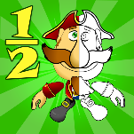
- Fractions Pirate
https://apps.apple.com/us/app/fractions-and-smart-pirates-free/id934802118

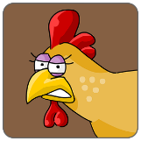
- Chicken Coop Fractions
https://apps.apple.com/us/app/chicken-coop-fraction-games/id484561886

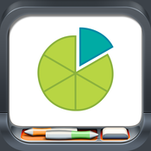
- Fractions
https://apps.apple.com/us/app/fractions-by-brainingcamp/id471353363

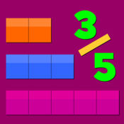
- Thinking Blocks Fractions
https://itunes.apple.com/us/app/thinking-blocks-fractions/id670767677?mt=8

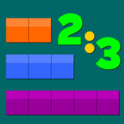
- Thinking Blocks Ratios
https://itunes.apple.com/us/app/thinking-blocks-ratios/id670448325?mt=8

