iPad Apps for 4th Grade

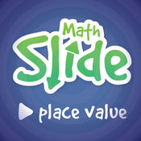
- Math Slide (Place Value)
https://itunes.apple.com/us/app/math-slide-place-value-school-edition/id601161731?mt=8
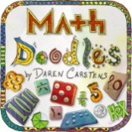
- Math Doodles
https://itunes.apple.com/us/app/math-doodles/id526959716?mt=8

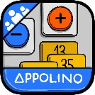
- Add & Subtract Appolino
https://itunes.apple.com/us/app/appolino-plus-minus-multiuser/id651406390?mt=8

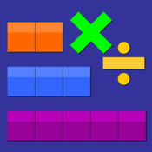
- Thinking Blocks Mult. & Div.
https://itunes.apple.com/us/app/thinkingblocksmultiplication/id669725575?mt=8

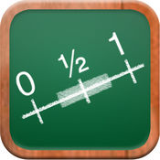
- Math Tappers Fractions
https://itunes.apple.com/us/app/mathtappers-estimate-fractions-math-game-to-help-children/id353282053?mt=8

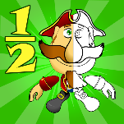
- Fractions Pirate
https://itunes.apple.com/us/app/fractions-and-smart-pirates-free/id934802118?mt=8

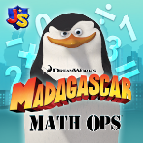
- Math Ops
https://itunes.apple.com/us/app/madagascar-math-ops-free/id640097569?mt=8

- Quick Fractions
https://itunes.apple.com/us/app/quick-fractions/id859831864?mt=8
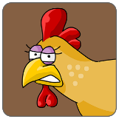
- Chicken Coop Fractions
https://itunes.apple.com/us/app/chicken-coop-fraction-games/id484561886?mt=8

- Oh No Fractions
https://itunes.apple.com/us/app/oh-no-fractions-curious-hat-lab/id593418681?mt=8

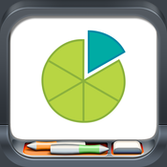
- Fractions
https://itunes.apple.com/us/app/fractionsbybrainingcamp/id471353363?mt=8
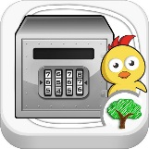
- Chicken Vault
https://itunes.apple.com/us/app/tiny-chicken-learns-rounding-numbers/id510574876?mt=8

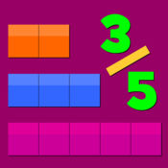
- Thinking Blocks Fractions
https://itunes.apple.com/us/app/thinking-blocks-fractions/id670767677?mt=8

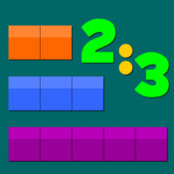
- Thinking Blocks Ratios
https://itunes.apple.com/us/app/thinking-blocks-ratios/id670448325?mt=8
- Pick-a-Path
https://itunes.apple.com/us/app/pick-a-path/id545185507?mt=8

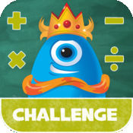
- Math Champ Challenge
https://itunes.apple.com/us/app/math-champ-challenge-common-core-standards/id566463831?mt=8

