iPad Apps for 3rd Grade

- Bedtime Math
https://apps.apple.com/us/app/bedtime-math/id637910701

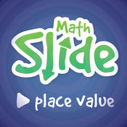
- Math Slide (Place Value) $
https://apps.apple.com/us/app/math-slide-place-value/id601161731

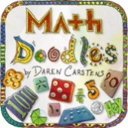
- Math Doodles $
https://apps.apple.com/us/app/math-doodles/id526959716

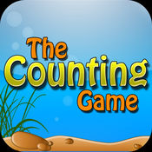
- The Counting Game $
https://apps.apple.com/us/app/the-counting-game/id452620847

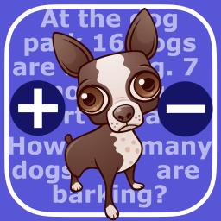
- Math Word Problems +/- (2 & 3)
https://apps.apple.com/us/app/math-word-problems-addition-subtraction-for-second/id827114226

- Math Claw
https://apps.apple.com/us/app/math-claw-machine-addition-subtraction-division-multiplication/id768575619

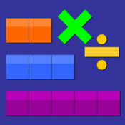
- Thinking Blocks Mult. & Div.
https://apps.apple.com/us/app/thinking-blocks-multiplication/id669725575

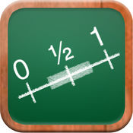
- Math Tappers Fractions
https://apps.apple.com/us/app/mathtappers-estimate-fractions-math-game-to-help-children/id353282053

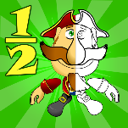
- Fractions Pirate
https://apps.apple.com/us/app/fractions-and-smart-pirates-free/id934802118
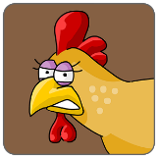
- Chicken Coop Fractions
https://apps.apple.com/us/app/chicken-coop-fraction-games/id484561886

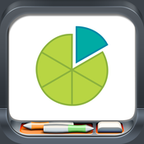
- Fractions
https://apps.apple.com/us/app/fractions-by-brainingcamp/id471353363

