iPad Apps for 3rd Grade

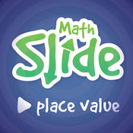
- Math Slide (Place Value)
https://itunes.apple.com/us/app/math-slide-place-value-school-edition/id601161731?mt=8
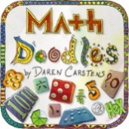
- Math Doodles
https://itunes.apple.com/us/app/math-doodles/id526959716?mt=8

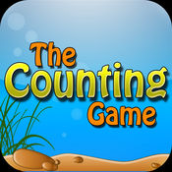
- The Counting Game
https://itunes.apple.com/us/app/the-counting-game/id452620847?mt=8

- Quick Clocks
https://itunes.apple.com/us/app/quick-clocks-telling-time/id565826811?mt=8

- Math Bugs
https://itunes.apple.com/us/app/id583921623

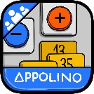
- Add & Subtract Appolino
https://itunes.apple.com/us/app/appolino-plus-minus-multiuser/id651406390?mt=8

- Math Claw
https://itunes.apple.com/us/app/math-claw-machine-addition-subtraction-division-multiplication/id768575619?mt=8

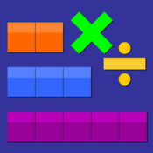
- Thinking Blocks Mult. & Div.
https://itunes.apple.com/us/app/thinkingblocksmultiplication/id669725575?mt=8

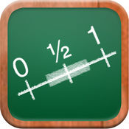
- Math Tappers Fractions
https://itunes.apple.com/us/app/mathtappers-estimate-fractions-math-game-to-help-children/id353282053?mt=8

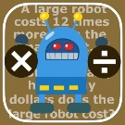
- Math Problems x/÷
https://itunes.apple.com/us/app/math-word-problems-multiplication-division-for-third/id820574139?mt=8
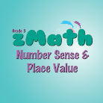
- Z Math Grade 3
https://itunes.apple.com/us/app/zmath-grade3/id588226328?mt=8

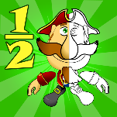
- Fractions Pirate
https://itunes.apple.com/us/app/fractions-and-smart-pirates-free/id934802118?mt=8

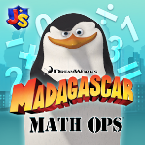
- Math Ops
https://itunes.apple.com/us/app/madagascar-math-ops-free/id640097569?mt=8
- Quick Fractions
https://itunes.apple.com/us/app/quick-fractions/id859831864?mt=8
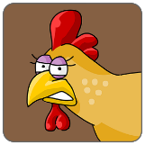
- Chicken Coop Fractions
https://itunes.apple.com/us/app/chicken-coop-fraction-games/id484561886?mt=8

- Oh No Fractions
https://itunes.apple.com/us/app/oh-no-fractions-curious-hat-lab/id593418681?mt=8

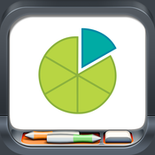
- Fractions
https://itunes.apple.com/us/app/fractionsbybrainingcamp/id471353363?mt=8

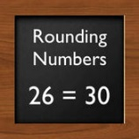
- Rounding
https://itunes.apple.com/us/app/roundingwholenumbers/id500845084?mt=8
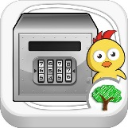
- Chicken Vault
https://itunes.apple.com/us/app/tiny-chicken-learns-rounding-numbers/id510574876?mt=8

