iPad Apps for 2nd Grade

- Bedtime Math
  - https://apps.apple.com/us/app/bedtime-math/id637910701

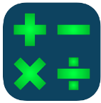
- Fast Facts Math $
https://apps.apple.com/us/app/fast-facts-math/id506232953

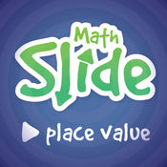
- Math Slide (Place Value) $
https://apps.apple.com/us/app/math-slide-place-value/id601161731

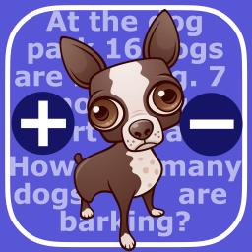
- Math Word Problems +/- (2 & 3)
https://apps.apple.com/us/app/math-word-problems-addition-subtraction-for-second/id827114226

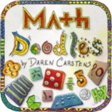
- Math Doodles $
https://apps.apple.com/us/app/math-doodles/id526959716

- Interactive Telling Time Lite
https://apps.apple.com/us/app/interactive-telling-time-lite-learning-to-tell-time-is-fun/id482452233

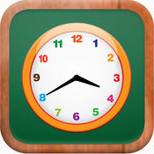
- Math Tappers: Clock Master
https://apps.apple.com/us/app/mathtappers-clockmaster-math-game-to-help-children/id336932114

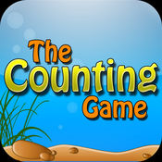
- The Counting Game $
https://apps.apple.com/us/app/the-counting-game/id452620847

- Math Claw
https://apps.apple.com/us/app/math-claw-machine-addition-subtraction-division-multiplication/id768575619

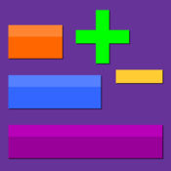
- Thinking Blocks +/-
https://apps.apple.com/us/app/thinking-blocks-addition/id668450919

