iPad Apps for 2nd Grade

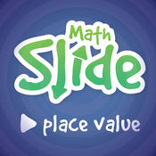
- Math Slide (Place Value)
https://itunes.apple.com/us/app/math-slide-place-value-school-edition/id601161731?mt=8

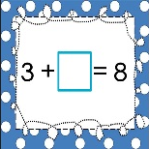
- + and –
https://itunes.apple.com/us/app/addition-and-subtraction-complete-the-equation-free/id866560633?mt=8

- Equalities
https://itunes.apple.com/us/app/comparing-numbers-greater-than-less-than-or-equal/id802040884?mt=8

- True or False
https://itunes.apple.com/us/app/true-or-false-math-equations/id792470464?mt=8

- Math Word Problems +/- (2 & 3)
https://itunes.apple.com/us/app/math-word-problems-addition-subtraction-for-second/id827114226?mt=8
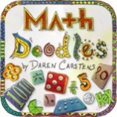
- Math Doodles
https://itunes.apple.com/us/app/math-doodles/id526959716?mt=8

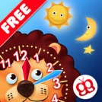
- Interactive Telling Time Lite
https://itunes.apple.com/us/app/interactive-telling-time-lite-learning-to-tell-time-is-fun/id482452233?mt=8

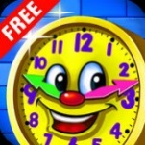
- Amazing Time
https://itunes.apple.com/us/app/amazing-time-telling-learning-time-games-for-kids-free/id598502334?mt=8

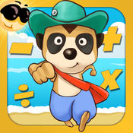
- Meerkat math
https://itunes.apple.com/us/app/meerkat-math/id571287803?mt=8

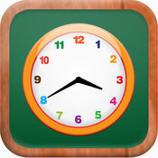
- Math Tappers: Clock Master
https://itunes.apple.com/us/app/mathtappers-clockmaster-math-game-to-help-children/id336932114?mt=8

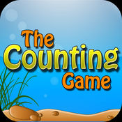
- The Counting Game
https://itunes.apple.com/us/app/the-counting-game/id452620847?mt=8

- Quick Clocks
https://itunes.apple.com/us/app/quick-clocks-telling-time/id565826811?mt=8

- Math Bugs
https://itunes.apple.com/us/app/id583921623

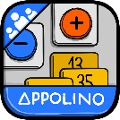
- Add & Subtract Appolino
https://itunes.apple.com/us/app/appolino-plus-minus-multiuser/id651406390?mt=8

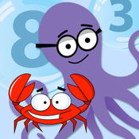
- Deep Sea Dual
https://itunes.apple.com/us/app/deep-sea-duel/id547246887?mt=8

- Math Claw
https://itunes.apple.com/us/app/math-claw-machine-addition-subtraction-division-multiplication/id768575619?mt=8

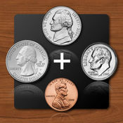
- Counting Money
https://itunes.apple.com/us/app/counting-money/id469420537?mt=8

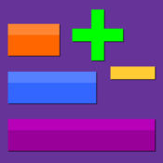
- Thinking Blocks +/-
https://itunes.apple.com/us/app/thinking-blocks-addition/id668450919?mt=8

