iPad Apps for 1st Grade

- Bedtime Math
https://apps.apple.com/us/app/bedtime-math/id637910701

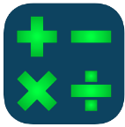
- Fast Facts Math $
https://apps.apple.com/us/app/fast-facts-math/id506232953
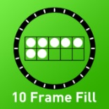
- 10 Frame Fill
https://apps.apple.com/us/app/10-frame-fill/id418083871
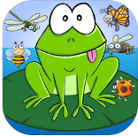
- Frog Hop
https://apps.apple.com/us/app/frog-hop-hd-math-problems/id585700693?ls=1
- Todo Math
https://apps.apple.com/us/app/todo-math/id666465255

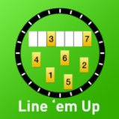
- Line ‘em Up
https://apps.apple.com/us/app/line-em-up/id419041848

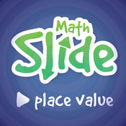
- Math Slide (Place Value) $
https://apps.apple.com/us/app/math-slide-place-value/id601161731

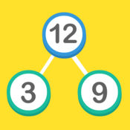
- Math Facts (number bond) $
https://apps.apple.com/us/app/maths-facts-number-bonds-fact-families/id459281769

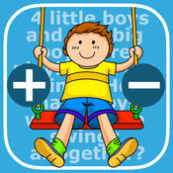
- Math Word Problems +/- (K & 1)
https://apps.apple.com/us/app/math-word-problems-addition-subtraction-for-kindergarten/id703753981
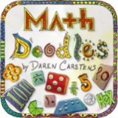
- Math Doodles $
https://apps.apple.com/us/app/math-doodles/id526959716

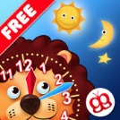
- Interactive Telling Time Lite
https://apps.apple.com/us/app/interactive-telling-time-lite-learning-to-tell-time-is-fun/id482452233

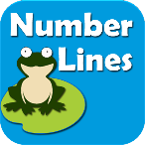
- Number Lines
https://apps.apple.com/us/app/teaching-number-lines/id492603378

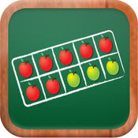
- MathTappers: Find Sums
https://apps.apple.com/us/app/mathtappers-find-sums-math-game-to-help-children-learn/id353582286
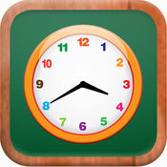
- Math Tappers: Clock Master
https://apps.apple.com/us/app/mathtappers-clockmaster-math-game-to-help-children/id336932114

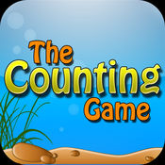
- The Counting Game $
https://apps.apple.com/us/app/the-counting-game/id452620847

