iPad Apps for 1st Grade
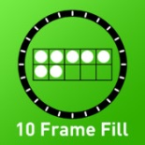
- 10 Frame Fill
https://itunes.apple.com/us/app/10-frame-fill/id418083871?mt=8

- Native Numbers
https://itunes.apple.com/us/app/native-numbers-complete-number-sense-mastery-curriculum/id570231808?mt=8
- Todo Math
https://itunes.apple.com/us/app/todo-math/id666465255?mt=8
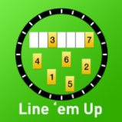
- Line ‘em Up
https://itunes.apple.com/us/app/line-em-up/id419041848?mt=8

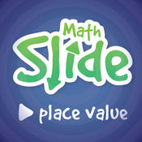
- Math Slide (Place Value)
https://itunes.apple.com/us/app/math-slide-place-value-school-edition/id601161731?mt=8

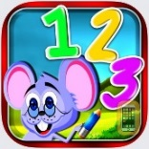
- Number Wonder
https://itunes.apple.com/au/app/number-wonder-teaching-math-skills-addition-subtraction/id839484092?mt=8

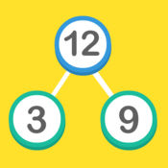
- Math Facts (number bond)
https://itunes.apple.com/us/app/maths-facts-number-bonds-fact-families/id459281769?mt=8

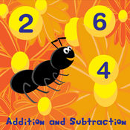
- Fact Families
https://itunes.apple.com/us/app/fact-families-addition-and-subtraction/id537645125?mt=8

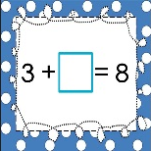
- + and –
https://itunes.apple.com/us/app/addition-and-subtraction-complete-the-equation-free/id866560633?mt=8

- Equalities
https://itunes.apple.com/us/app/comparing-numbers-greater-than-less-than-or-equal/id802040884?mt=8

- True or False
https://itunes.apple.com/us/app/true-or-false-math-equations/id792470464?mt=8
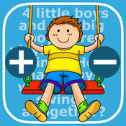
- Math Word Problems +/- (K & 1)
https://itunes.apple.com/us/app/math-word-problems-addition-subtraction-for-kindergarten/id703753981?mt=8

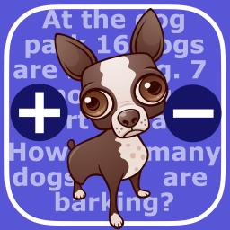
- Math Word Problems +/- (2 & 3)
https://itunes.apple.com/us/app/math-word-problems-addition-subtraction-for-second/id827114226?mt=8
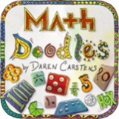
- Math Doodles
https://itunes.apple.com/us/app/math-doodles/id526959716?mt=8

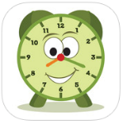
- Tell Time Lite
https://itunes.apple.com/us/app/tell-time-little-matchups-game/id440944851?mt=8

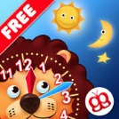
- Interactive Telling Time Lite
https://itunes.apple.com/us/app/interactive-telling-time-lite-learning-to-tell-time-is-fun/id482452233?mt=8

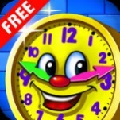
- Amazing Time
https://itunes.apple.com/us/app/amazing-time-telling-learning-time-games-for-kids-free/id598502334?mt=8

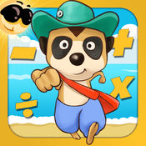
- Meerkat math
https://itunes.apple.com/us/app/meerkat-math/id571287803?mt=8

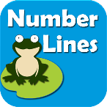
- Number Lines
https://itunes.apple.com/us/app/teaching-number-lines/id492603378?mt=8

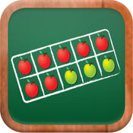
- Math Tappers: Find Sums
https://itunes.apple.com/us/app/mathtappers-find-sums-math-game-to-help-children-learn/id353582286?mt=8
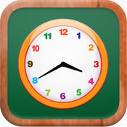
- Math Tappers: Clock Master
https://itunes.apple.com/us/app/mathtappers-clockmaster-math-game-to-help-children/id336932114?mt=8

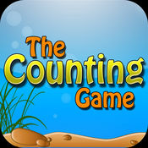
- The Counting Game
https://itunes.apple.com/us/app/the-counting-game/id452620847?mt=8

